# LibreHealth EHR Installation Instructions

## Introduction

This document provides step-by-step instructions to install the LibreHealth EHR system on a local Ubuntu machine. The instructions below apply to Linux systems. They might need modification for other operating systems (Windows, OS X).

I created this documentation as a starter task for the Outreachy 2020 internship applications and I’m looking forward to continuing contributing to LibreHealth EHR.

Pranathi Ernala, 5 April 2020.

## Procedure

1. Install Composer, Docker and docker-compose for Ubuntu which are requirements to run the LibreHealth EHR system locally. To install Composer and Docker, follow the instructions at the below links:
   1. Step 1: [Composer Getting Started](https://getcomposer.org/)
   2. Step 2: [Docker CE install Page](https://docs.docker.com/install/overview/)
   3. Step 3: [Docker Compose install Page](https://docs.docker.com/compose/install/#install-compose)

Note: Ensure that you install the latest version of Docker for steps 2 and 3 above. This helps eliminate some warnings that might appear downstream in this installation.

1. Obtain the source code for LibreHealth EHR by running the following command

*$ git clone* [*https://github.com/LibreHealthIO/lh-ehr.git*](https://github.com/LibreHealthIO/lh-ehr.git)

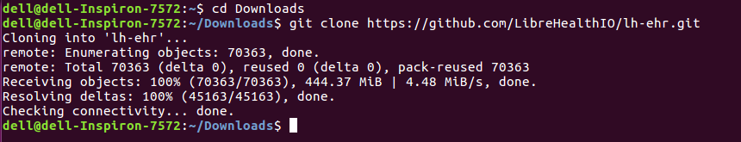

1. Install [GNU awk (gawk)](https://www.gnu.org/software/gawk/) by running the following command

*$ sudo apt update; sudo apt install gawk*

1. Before proceeding to the next steps, ensure that you are inside the lh-er folder while running the commands. You can do this by running the following command from the directory where you downloaded the source code.

*$ cd lh-ehr*

1. Ensure that your user is part of the docker user group. To add your user to the docker user group run the below command.

*$ sudo usermod -aG docker $USER*

1. For a local installation, the instructions recommend running a developer install. Do not proceed with a production install. To set up the developer install, run the following command. This uses the default docker-compose.yml file to setup Docker and automatically imports a demo database.

*$ docker/dev setup*

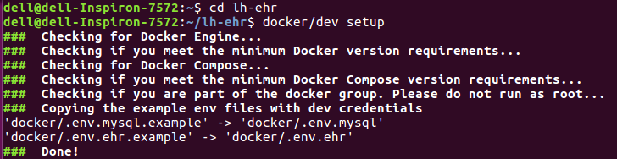

1. Step 6 also checks if your user is part of the docker user group. In case you face an error here, repeat step 5 or run the following command. If you don’t see any errors, move on to step 8.

*$ sudo gpasswd -a $USER docker*

1. If the setup does not throw any errors, start the docker containers by running the following command. The initial container creation may take some time.

*$ docker/dev start*

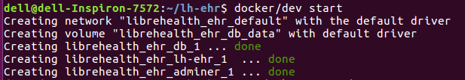

1. The LibreHealth EHR system should now be running locally on the machine.
2. Find the local IP address of the server where Docker is running. To get the IP address, run this command:

*$ ifconfig -a*

1. Look for the IP address where docker is running.

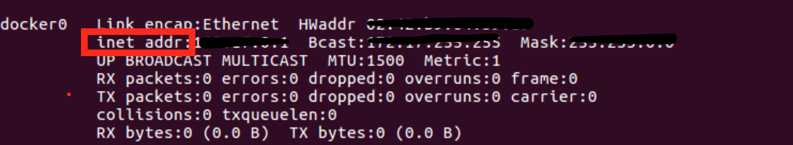

1. Open a browser and go to the IP address from step 11.
2. Login to the EHR system. The initial credentials are username = admin, password =

password.



## Summary

This document provides step-by-step instructions to install the LibreHealth EHR system using Docker on Ubuntu systems.